Conjoint Analysis Assignment

Cade Muntz

**Overview**

We have been hired by a hotel owner to gain more insight into his business customers preferences. They would like to remodel some of their rooms to better cater to their business clients. However, the owner is not sure what these business clients would like their rooms to offer. Overall, they want to understand how changing the rooms will affect business clients decision making and influence. Therefore, we are here to help them solve this problem. We will be looking into how to optimize the design for the new rooms with regard to their clients preferences, while still maximizing market share and revenue.

The model we will be using to solve this problem is a conjoint analysis. This model is the best model for this data because of how well it fits the problem. To begin a conjoint analysis, the clients are asked to compare different features the hotel has to offer with respect to one another. We then run a conjoint analysis which will determine how the customers value each amenity when compared to one another, effectively answering the question which the business owner has tasked us to solve.

**Initial Insights**

We started off by running a conjoint analysis on the different factors that may affect a guest's stay. These factors are separated into 5 different categories. These factors / categories are -

* Room
  + Small Suite
  + Large Room
  + Room Office
* Business Amenities
  + Free WiFi
  + In-Room Printing
  + Free in/out Shipping
* Exercise Equipment
  + Hotel gym only
  + In-room Equipment Only
  + In-room Equipment / Hotel Gym
* Extras
  + Shoe Shine
  + Premium Cable
  + Dry Cleaning
  + Newspaper
* Restaurant Delivery
  + Restaurant Delivery
  + No Restaurant Delivery

**Conjoint Analysis**

After running a conjoint analysis we are greeted with a results table showing the utility numbers which show us how much an attribute is worth comparatively within each category. The table can be seen below.

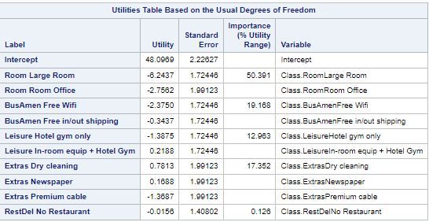

As can be seen by this chart, the room category is the most impactful when it comes to customer satisfaction. Whereas, whether or not they have food delivery is not very important at all. Based on this, we can help make justified conclusions when the time comes, as we can view this chart and see how important an attribute may be to a customer, and decide if removing / keeping the attribute is worth it.

Another thing we can consider is looking at the individual attributes utilities within each category. See the chart below for a more visualized view.

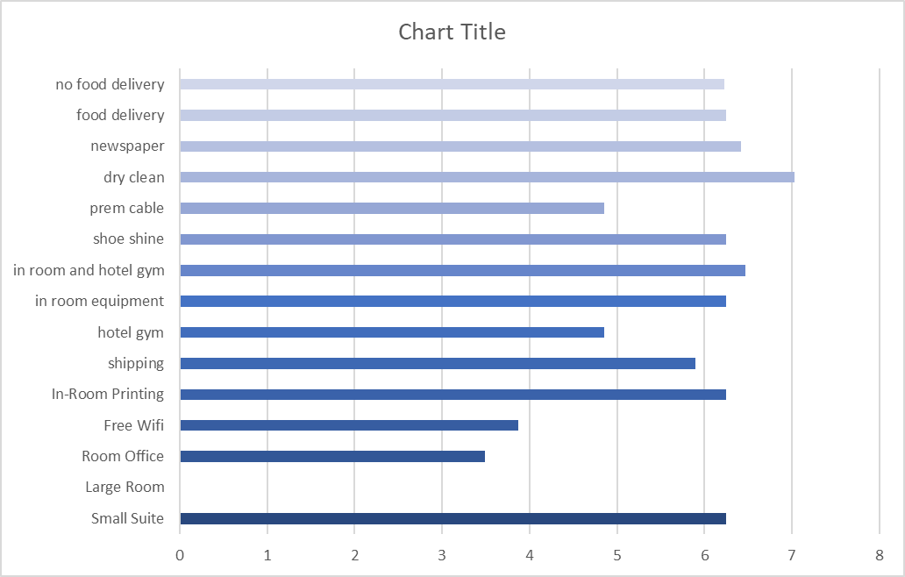

As seen by this chart, we can conclude a few things.

* Clients heavily prefer a Small Suite over the other 2 room options, and considering room accounted for 50% of importance, this is something to consider
* Customers do not seem to care about food delivery, and taking out food delivery will likely not make too big of a difference.
* Customers prefer dry cleaning, but it may be worth considering the costs versus impact between that and newspapers./ shoe shine
* The customers do not care for the hotel gym, and it may be worth looking into in room equipment instead
* Customers do not care for the free wifi, and would prefer in-room printing, with shipping right behind it.

If we are going directly off of the chart, the ideal room design for these customers would be a room that includes, Food Delivery, Dry cleaning, in room / hotel gym, printing, and a small suite. However, next we need to consider whether or not this room is ideal from a profitability standpoint, while also considering our customer’s opinions. Therefore, we will try to find a room that will not only keep customers happy, but maximize our profitability at the same time.

**Findings**

To find the ideal room, we have to consider other factors, than just the most ideal room from a customer perspective. This is because customers are likely to choose options that are the best, but also the most expensive, which may not be beneficial to use from a profitability perspective. Down below is a table which shows our profitability levels compared to one another.

| Attributes / Levels | Room | Bus Amenities | Leisure | Extras | Rest Delivery |
| --- | --- | --- | --- | --- | --- |
| Level 1 | -2 | 0 | 0 | -0.25 | 0 |
| Level 2 | 0 | -1 | -2 | 0 | 2 |
| Level 3 | -1 | -0.5 | -2 | -2 |  |
| Level 4 |  |  |  | 0 |  |
|  |  |  |  |  |  |
| Levels | Room | Bus Amenities | Exercise Equipment | Extras | Rest Delivery |
| Level 1 | Small Suite | Free Wifi | Hotel gym only | Shoe shine | Restaurant |
| Level 2 | Large Room | In-room printing | In-room equipment only | Premium Cable | No Restaurant |
| Level 3 | Room Office | Free in/out shipping | In-room equip + Hotel Gym | Dry cleaning |  |
| Level 4 |  |  |  | Newspaper |  |

Using this table, alongside the chart and graph, we can see that the ideal room from a profitability standpoint would be a room that includes a small suite, free wifi, hotel gym only, premium cable / newspaper, and no restaurant delivery. Comparing this to our customers ideal room, we can make some changes.

First off, since room is by far the most important attribute to customers, we will give them what they want, in a small suite. While this costs us the most, it should be good in the long run strictly due to how much more customers prefer a small suite over the other two rooms. In terms of business amenities, customers did not care for the free wifi at all. They instead cared the most for in room printing or shipping. To maximize profitability, and satisfaction, shipping is likely the best candidate here. As this was only slightly behind printing in client satisfaction, while being cheaper.

The hotel gym is the cheapest option, however, customers did not care for it whatsoever. Considering customers cared more for the hotel gym and in room equipment option, and in room equipment by itself costs the same as them together, we believe it would be wise to add on in-room equipment and keep the gym. This gives them the option to possibly renovate the gym in the future.

For extras, cable and newspaper are the cheapest, with dry cleaning being the most desirable and most expensive. However, since newspaper was not very far behind dry cleaning, putting newspaper in with a much lower price point would be the option to choose in this case. Adding shoe shine may also help differentiate themselves amongst competition, while offering a lower price point. As well as removing restaurant delivery, as clients do not seem to care whether or not they get restaurant delivery, and removing it will make us money.

Based on these results, the ideal room would be a room consisting of a small suite, shipping, in room equipment + gym, newspaper and shoeshine, and no restaurant delivery. When it comes down to it, this will give us the best satisfaction while maximizing profitability. Based on the chart, this room will cost us -2.75 based on that scale, whereas the customer's ideal room would have cost us -7. Not only are we losing much less money, but we are only losing a slight amount of customer satisfaction, meaning that the benefits should outway the costs.

**Recommendations**

Using this ideal room, the hotel manager should look at trying to differentiate themselves from the competition. Their main selling points should be that they include a small suite, with a hotel gym and in room equipment, while also having free shipping and a shoe shine. Most of their competitors do not carry free shipping, however two competitors do include both a small suite and a hotel gym / in room equipment. However, by advertising they have free shipping, this may appeal to a different customer segment that the other hotels have not tapped into. Also, considering that based on the chart, plenty of customers were looking for free shipping, this should be a good selling point for them. However, adding shoe shine heavily differentiates themselves from the competition. The only other competitor which includes a shoe shine in their package does not include a small suite, which is the main factor for customer satisfaction.

It also may be worth looking into removing the hotel gym and turning it into something that could provide more value to the hotel. The reason they may want to consider this option is because the clients currently do not care for the hotel at all. If the hotel were converted into something better for the clients then this could keep customers happy with the in room exercise while also adding more to the hotel to further differentiate themselves. This could be something like a pool room which could be a place of relaxation for the customers. Or better yet, some sort of on site bar as this could bring the hotel immense value from the drink prices, while bringing customers in for a unique experience.

Essentially, we recommend that the hotel uses a room consisting of a small suite, free shipping, a hotel gym with in room equipment, a newspaper and a shoe shine, as well as no restaurant. The hotel should also look into ways they could transform the hotel gym into something that brings them more value. This will help differentiate themselves from the competition as most of the competitors do not include free shipping or a shoe shine. With this room design, they should be able to maximize profits, while keeping customers engaged with their brand.